Procedures to use Official Records Search website
In the web address bar put the following or click the link: http://ori.indian‐river.org/Home/Index

- Go to the Clerk’s website.
- Click on the lady with the green sweater to search by name
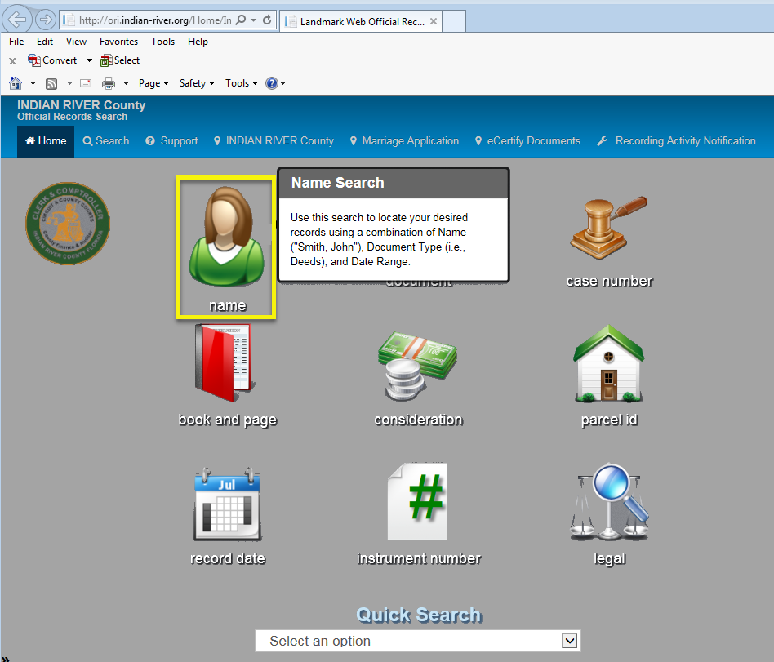

OR
- Click on the red book to search by book and page.
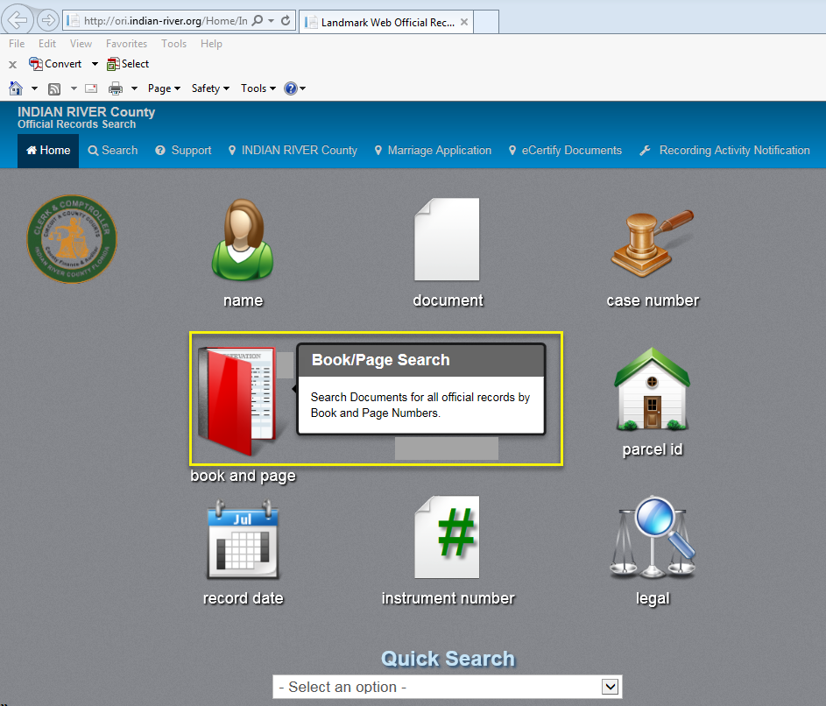

Page 2
- Accept the conditions of the Disclaimer.
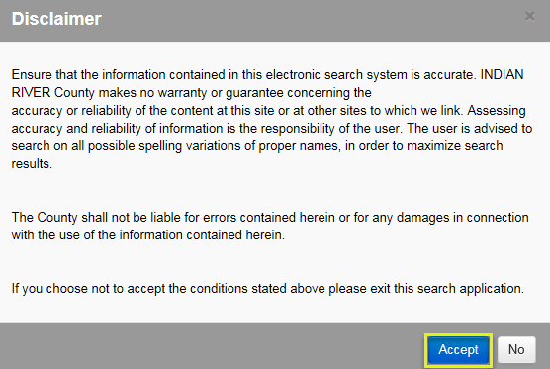

- Click on the empty field beside NAME* and enter the name of whoever you want to search Lastname,Firstname just like that. Smith,John. If you want to search a company name, type it straight out. Don’t touch any of the other fields. Click the SUBMIT button.
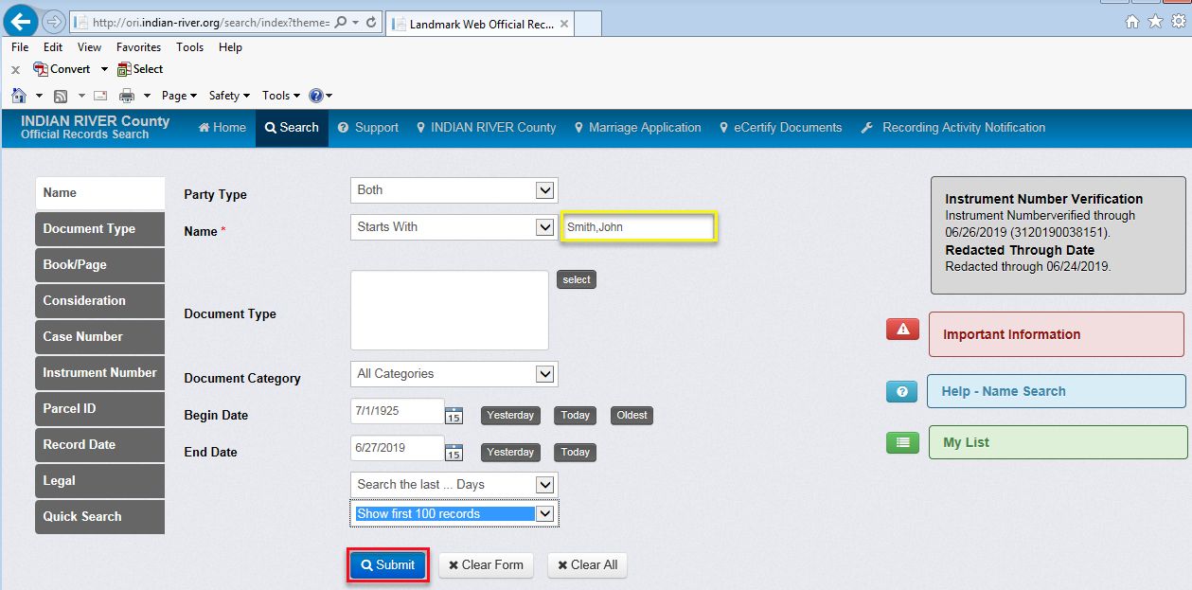

- Choose the book type you wish to search.
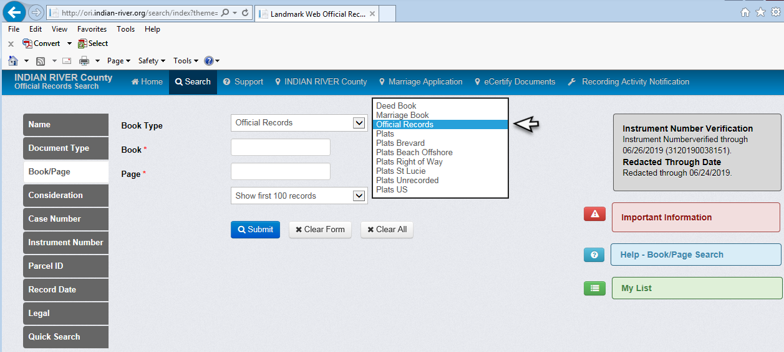

Page 3
- The list of search results will appear at the bottom of the screen. Scroll down to see. Mouse over the list to highlight a particular document. Double click anywhere on any line to open that document.

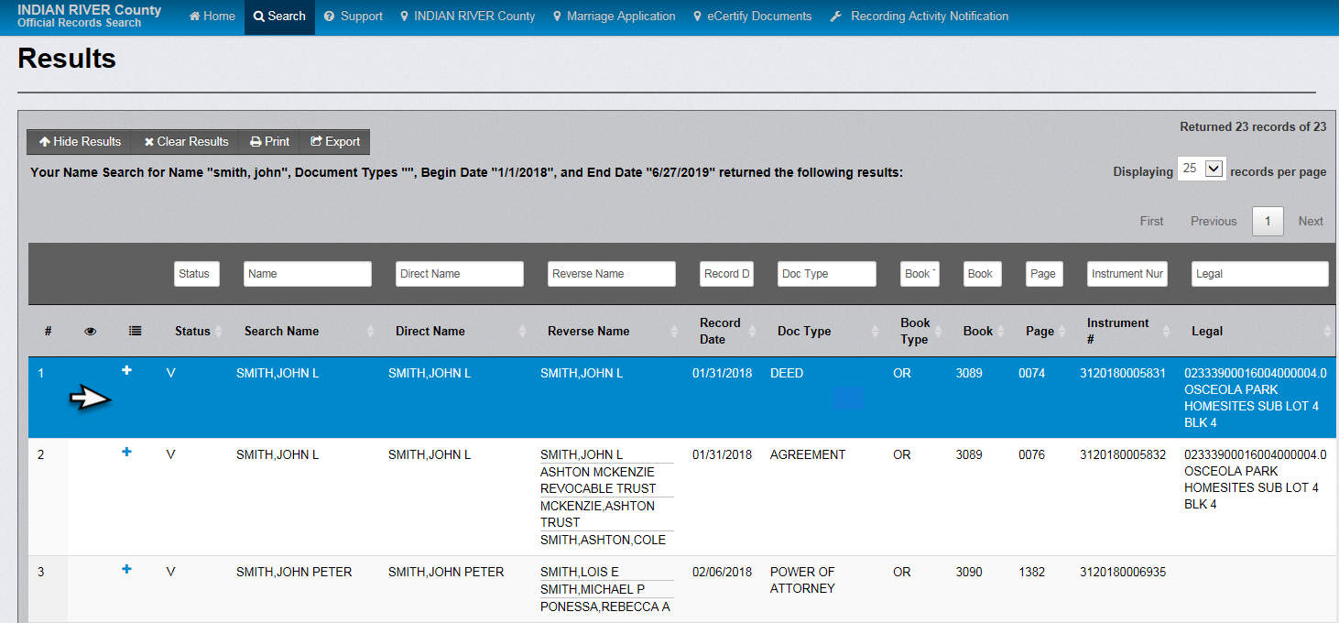

- Click on VIEW above the image of the document (Choose Preview All Pages from the pulldown) to open it in ADOBE READER.

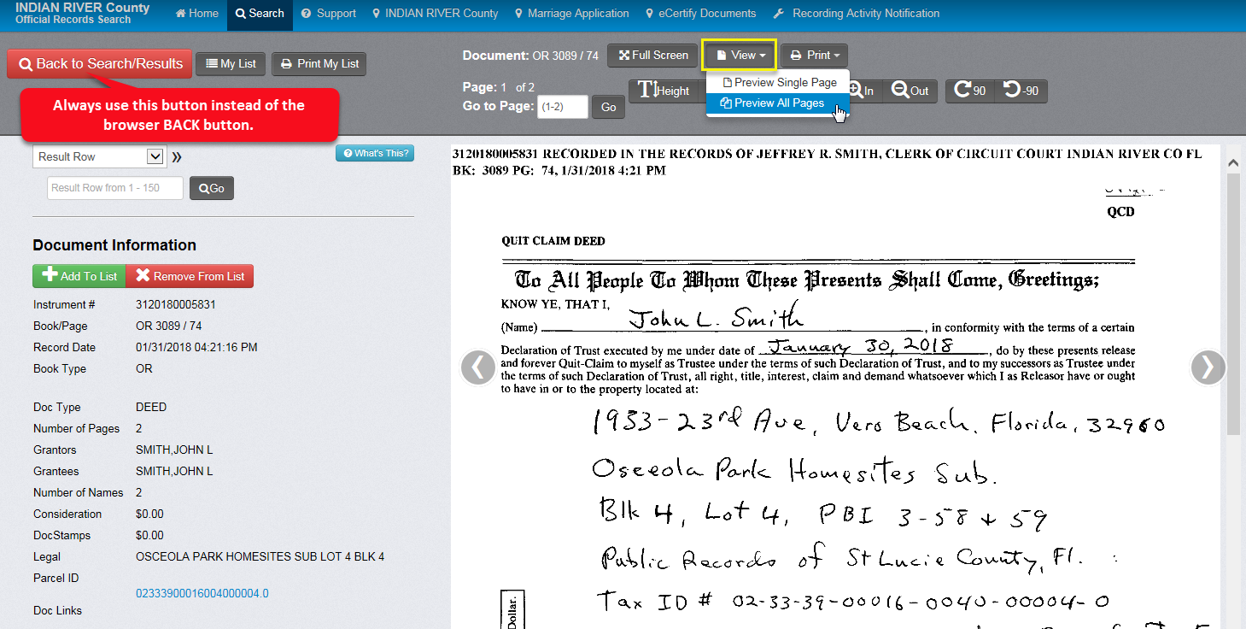

Page 4

- Mouse over the image to bring up the tool bar. You can use the tools to SAVE or PRINT the document from there (the tools might appear differently depending on your version of ADOBE READER).
